Evaluation of the Australian Government’s Investment in Aboriginal and Torres Strait Islander Primary Health Care through the Indigenous Australians’ Health Programme
Monitoring and Evaluation Design Report
Executive Summary
26 July 2018

Acknowledgements
Acknowledgement of Country. In the spirit of respect and reconciliation, the evaluation team acknowledge and pay respect to the Traditional Custodians of Australia – the Aboriginal and Torres Strait Islander people, and their continuing connection to land, waters, sea and community.
Acknowledgement of Evaluation Co-design Partners. The Indigenous Australians’ Health Programme (IAHP) evaluation team would like to express our appreciation to the members of the Health Sector Co-design Group who worked alongside and robustly engaged with the IAHP evaluation team and the Department of Health on the design of the evaluation of the Australian Government’s investment in Aboriginal and Torres Strait Islander Primary Health Care through the Indigenous Australians’ Health Programme.
In the evaluation co-design phase, the members of the Health Sector Co-design Group were Ms Kate Thomann and Dr Mark Wenitong (who co-chaired the group), Dr Dawn Casey, Ms Janine Mohamed, Mr Karl Briscoe, Ms Angela Young, Prof Norm Sheehan, Ms Jessica Yamaguchi, Ms Karen Visser, Dr Fadwa Al-Yaman, Ms Kim Grey, Dr Jeanette Ward and Ms Nicki Herriot.
Acknowledgement of jurisdictional and community organisations. The IAHP evaluation team would also like to thank people from the state/territory health organisations, the peak bodies and community members who also gave their time and ideas to ensure that the design of the evaluation would meet a wide range of needs.
About the artist and artwork: The artwork for this report and other IAHP evaluation documents was produced by Emma Walke. Emma is a Bundjalung Aboriginal woman from northern New South Wales (NSW) and is on the evaluation team. The following is her description of the artwork:
Because I don’t speak for every Country, and because we are working across many of them, the work seeks to represent Indigenous Australia. I feel that colour makes a statement so I have used colours that can be linked to many of our communities and Countries, land or sea based. The colours represent our people and the land they come from – ochres/yellows represent desert and hills and the cliffs where our ochres come from. Blues for ocean and blue greens for rivers.
The circles are universal in the way they represent groups or clans of people, the markings inside some of the circles represent individuals.
The dots and slashes are representational of tracks and time lines. There are a few blank circles – they represent the missing, the lost peoples.
I thought I would try and incorporate the colours to show respect for them.

Introduction
This report outlines the design of a four-year evaluation of the Australian Government’s investment in Aboriginal and Torres Strait Islander primary health care, which occurs primarily through the Department of Health’s (DOH) Indigenous Australians’ Health Programme or IAHP. The evaluation design encompasses the purpose of the evaluation, the evaluation questions, methodological design and rationale, data, implementation plan, analysis of opportunities, limitations and risks, and a communications and dissemination strategy.
Key Evaluation Questions
- How well is the IAHP enabling the primary health care system to work for Aboriginal and Torres Strait Islander people?
- What difference is the IAHP making to the primary health care system?
- What difference is the IAHP making to the health and wellbeing of Aboriginal and Torres Strait Islander people?
- How can faster progress be made towards improving the health and wellbeing of Aboriginal and Torres Strait Islander people?
Purpose of the evaluation
The evaluation will:
- Demonstrate the difference that the IAHP is making or not making to the primary health care system and Aboriginal and Torres Strait Islander people’s health and wellbeing.
- Support the continuous improvement of IAHP policy, planning and decision making.
- Support PHC providers and other key organisations to improve and adapt the quality and ability of their services to achieve better outcomes for the health and wellbeing of Aboriginal and Torres Strait Islander people.
Aboriginal and Torres Strait Islander people’s needs and aspirations for their health and wellbeing, and for comprehensive PHC, are to be central to the evaluation.
As such, the purpose of the evaluation is to create and expedite real change in Aboriginal and Torres Strait Islander people’s health and wellbeing through supporting improvements in the IAHP and its interaction with the primary health care and broader health system. It is also to facilitate learning and action within and between the different levels of the health system – local, regional, state/territory and national.

Overview of the approach for conducting the evaluation
The evaluation design is illustrated below. The design involves a wide range of stakeholders taking part in developmental, cyclic processes at different levels of the system – local/regional communities and providers in system-focused site studies, organisational stakeholders in state/territory and national engagements, and various groups of stakeholders in collaboratives to address cross-cutting themes – to address the evaluation questions. The repeating cyclic processes are focused on the co-creation of knowledge and, importantly, action. This will enable the evaluation to be responsive to exploring and testing emerging findings.

Overview of the evaluation design

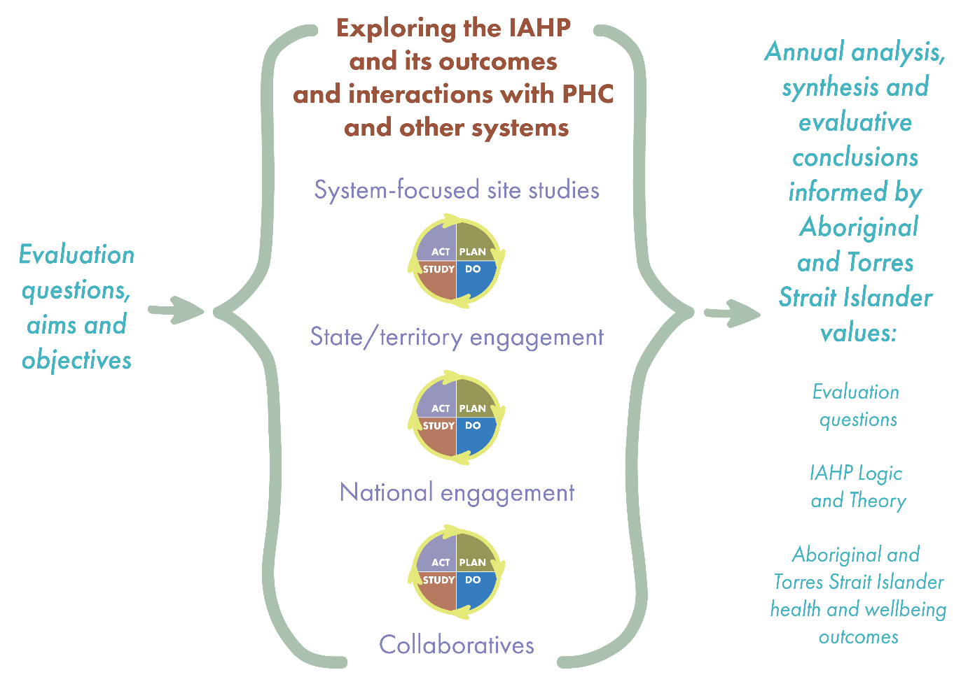
Overarching analysis, synthesis and national reporting on the evaluation questions, and IAHP logic and theory will occur annually. The emerging findings from the analysis and synthesis will be discussed and interpreted with all evaluation participants in the co-creation and collaborative sessions, and an annual interim national evaluation report and summary version made available.
The system-focused site studies will include a range of communities, population groups and providers as illustrated below.

Two levels of involvement will be offered to local/regional sites in recognition of the variance in local circumstances that can impact on capacity to participate in an evaluation – involvement as general or in-depth sites. General sites will entail a lower level of intensity that includes analysis of nationally available quantitative data for that site, key informant interviews and co-creation sessions. In addition, in-depth sites will involve more intensive data gathering and analysis, and include clinical indicator data, more in-depth interviews and community focus groups.

System-focused site studies

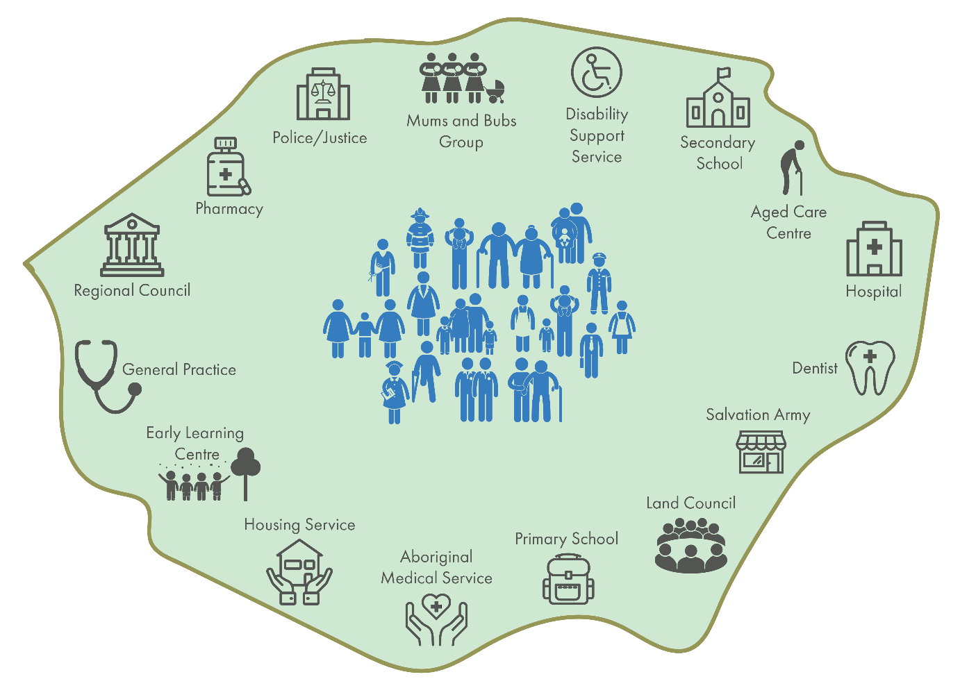

Key elements of the system-focused site studies:
- Local evaluation governance, including ongoing reflection on the appropriate conduct and local value of the evaluation activities.
- Co-designed tailored evaluation plans within the framework of the overall evaluation design.
- Mapping of the provision of services and IAHP funding and programs, and contextual descriptions.
- Quantitative data – baseline data followed by annually updated data reports, and sessions making meaning of the data.
- Qualitative data-gathering – stories of the experiences of people who use and do not use PHC services, and from people who manage and deliver these services.
- Co-creation sessions – communities and providers coming together to problem solve, analyse and interpret data, discuss and interpret emerging evaluation findings, and identify solutions and actions.
- Capability building, reciprocity and resourcing for participation in the evaluation.

20-24 system-focused site studies
The evaluation strongly recommends that between 20 to 24 system-focused site studies occur, with half of these studies general and half in-depth. The two types of sites provide both breadth and an ability to generalise findings (including the ability to compare and contrast) and enable an understanding of what works, for whom and in what circumstances (due to in-depth study). A large number of studies is proposed to account for variations in PHC service models and models of care, geography, population density and diversity, distinct population groups (particularly those that are hard to reach), levels of IAHP funding, and progress on key indicators.
Along with the state/territory and national engagements, 20–24 site studies will achieve the ‘evidence’ objective for the evaluation by enabling a contextualised, in-depth understanding of the operation and outcomes of the IAHP and its interactions with the PHC and other important systems, programs and factors. State/territory and national engagements, along with the large number of sites, will also achieve the ‘change’ objective for the evaluation, that is, enable proactive improvements to the IAHP during the four-year evaluation.

State/territory and national engagement
The state/territory and national engagements will follow a similar pattern to the site studies – with tailored evaluation plans, descriptions of responsibilities for and provision of IAHP funding and programs, relevant quantative data analyses, qualitative data gathering, and co-creation sessions.

The evaluation design has been developed:
- To facilitate co-design, co-creation, relational, honest and empowering processes that are, where possible, led by or co-led with Aboriginal and Torres Strait Islander people, with appropriate co-leadership, resourcing and support from the evaluation team.
- To create multiple opportunities for Aboriginal and Torres Strait Islander people and other key stakeholders – policy makers, practitioners and community members across Australia and the PHC system – to come together and problem solve, analyse and interpret data, discuss emerging evaluation findings, and identify solutions and actions via ‘co-creation’ sessions (site-based) and ‘collaboratives’ (based on emerging themes or issues common to sites, groups, organisations or stakeholders across geographical areas).
- To offer sites varying levels of involvement in the evaluation in recognition of their different capacities and competing priorities.
- To provide recent, analysed data and facilitate data-making meaning sessions so communities and providers can make decisions using their own data.
- To ensure the evaluation is responsive to emerging findings and opportunities to create substantial change, while answering the key evaluation and other questions, and testing the logic and theory of change for the IAHP.
Plan for conducting the evaluation
Year 1 Co-design establishment:
Selecting and establishing the site studies, and engaging national and state/territory stakeholders, will be a key focus of the first year of the evaluation. Health Partnership Forums will assist with the selection of the sites.
Another key focus will be a feasibility analysis of potential quantitative data sources, and the development of a detailed plan for answering the range of evaluation questions, and exploring the IAHP logic and theory, based on the selection of the sites and available quantitative data.
The outputs from Year 1 will be a site selection report; tailored site evaluation plans; service provision maps and contextual descriptions; quantitative and qualitative data protocols, indicators and tools; baseline quantitative data reports; an ethics application; and an interim national evaluation report.
Years 2 and 3 Co-creation of knowledge and action across the site studies, state/territory and national engagements, and through the emergence of collaboratives:
The evaluation activity will be guided by a Plan-Do-Study-Act cycle:
- The ‘Plan’ component of the cycle involves reflecting on, and adapting as needed, the overall and tailored evaluation plans; development of qualitative fieldwork tools, training and piloting; and the preparation of quantitative data reports.
- The ‘Do’ component involves co-creation sessions focused on making meaning of data and qualitative fieldwork.
- The ‘Study’ component involves co-creation and collaborative sessions focused on the production of knowledge and action. Emerging evaluation findings will be presented and analysed as part of these sessions.
- The ‘Act’ component of the cycle involves the site, state/territory, national and collaborative participants taking action as identified in the co-creation sessions.
- The number of site visits per year, and the visitation processes, will be agreed as part of the co-design with each site. Similarly, the number of state/territory and national engagements will be agreed as part of a co-design process with these stakeholders.
Collaboratives
The need for a collaborative will arise through the analysis of quantitative data and qualitative information gathered through fieldwork across sites, and from the national and state/territory engagements. It may also emerge through stakeholders expressing a strong interest in working on a specific issue that addresses the evaluation aims, objectives and questions described on the first page of the Executive Summary.
Outputs
The outputs from both Years 2 and 3 are quantitative data reports for each of the sites, for state/territory and national engagements, and for the collaboratives; a progress report to the DOH in March; and an interim national evaluation report and associated summary report in October. There will also be summaries of each of the co-creation and collaborative sessions reported back to participants.
Reflection
Each year or cycle, a visit or engagement will conclude with a reflection process that will check on progress against, and the relevancy of, the tailored evaluation plans, any updates needed for these plans, how well the evaluation process is working, and what could be improved.
Year 4 – Transitioning the evaluation and final reporting:
As well as continuing the co-creation of knowledge and action, the last year of the evaluation will focus particularly on the evaluation processes valued by sites and other stakeholders, how these could be transferred and sustained, and recommend an approach for monitoring and evaluating the Australian Government’s Aboriginal and Torres Strait Islander-specific PHC investment over the longer term. The fourth year will also focus on drafting the final report and working with evaluation participants on the conclusions and recommendations to inform policy settings and program implementation.
Data
Based on the quantitative data feasibility analysis in Year 1:
- The general site data reports will include analyses of population data, site characteristics data, IAHP data, nKPI and OSR data and nationally available clinical data. It may include analyses of administrative data and hospitalisations, mortality and morbidity data.
- The in-depth sites will include analysis of additional local and clinical data as well as the data listed for the general sites.
- State/territory data reports will include an analysis of site data for their state/territory, data for all sites for all of Australia, and data for all Australia
- National data reports will include an analysis of all the site data and the data for the rest of Australia.
- Site, state/territory and national participants will be provided with an initial baseline quantitative data followed by annual updates.
Analyses of the quantitative and qualitative data will be undertaken at each level – site, state/territory and national – along with relevant comparative analyses to explore factors that can help to explain similarities and differences. These will be reported back and discussed with the participants as part of the making meaning component of the co-creation sessions.
There is already a wealth of existing research literature on Aboriginal and Torres Strait Islander people’s health and related factors, and their experiences and perspectives. This information will also be drawn on to explore and understand emerging findings in more detail and to inform proposed actions.
Monitoring
A monitoring program will be put in place following both the feasibility analysis of potential quantitative data sources, and the development of a detailed plan for answering the evaluation questions in Year 1. The monitoring program will include three components:
- The annual quantitative data reports.
- Tracking the learnings and changes resulting from the evaluation process.
- Tracking the actions undertaken by participants as a result of the co-creation and collaborative sessions.
Governance
The evaluation will operate under multiple levels of governance – the Department of Health (the commissioner of the evaluation), a Health Sector Co-design Group (HSCG) and a Community Co-design Group (CCG) (national groups that will meet six-monthy), and local governance for each of the sites.
The evaluation team will also establish an independent Technical Reference Group composed of experts in primary health care and evaluation, health systems and systems thinking, Indigenous data, and co-design, design-led and other learning approaches relevant to the evaluation.
A set of guiding ethical principles and identified evaluation standards have already been developed. The evaluation will need ethics approval, and this will likely be sought from the Australian Institute of Aboriginal and Torres Strait Islander Studies (AIATSIS) Research Ethics Committee given the recent disbandment of the DOH’s Human Research Ethics Committee.

Methodological approaches
Underpinning the evaluation design is the developmental evaluation approach, complemented by process and impact evaluations. The approach also draws on co-design and co-creation, continuous quality improvement and participatory methods, systems thinking, theory-driven and realist evaluation, evaluation-specific logic, and explicit processes for working with both Aboriginal and Torres Strait Islander and Western knowledge systems. The evaluation recognises the centrality of culture, and the impact of social, economic, political and cultural determinants on health outcomes.
What people told us is important
We have designed the evaluation so that we can address substantively what people who were part of its co-design highlighted, namely:
- There is a great opportunity to make better use of existing data, as although the data are reported into the system not enough information is reported back out to services in a timely fashion.
- While data tells one story, narratives on people’s experiences and aspirations are also key. There is a need to look at measures beyond health service coverage and health status.
- It is important to look ‘inwards’ at the IAHP’s policy and grant management processes and systems, as well as assessing service delivery and impacts for the Aboriginal and Torres Strait Islander population.
- Co-designing the problems that the IAHP is intended to solve is key to co-designing the solutions, otherwise different conceptualisations of the problem will most likely result in disparate solutions.
- An ecological (whole-of-system) and adaptable approach to evaluation is needed, one that can respond to important emerging areas of inquiry.
- Strengths-based approaches are vital, ones that share and celebrate the success, strength, resilience and capabilities of Aboriginal and Torres Strait Islander people.

Recommended citation: Bailey, R., Hardie-Boys, N., Bailie, J., Carr, J., Moodie, D., McLean, G., Scanlen, A., Bainbridge, R., Monaghan, R., Walke, E., & Bailie, R. Evaluation of the Australian Government’s Investment in Aboriginal and Torres Strait Islander Primary Health Care through the Indigenous Australians’ Health Programme: Monitoring and Evaluation Design Report Executive Summary. Wellington: Allen + Clarke, 2018.
The evaluation team who undertook the co-design project resulting in this Monitoring and Evaluation Design Report was led by Allen + Clarke and consisted of the following members and partner organisations:

Matt Allen | Project sponsor | Allen + Clarke
Ned Hardie-Boys | Team leader | Allen + Clarke
Dr Ross Bailie | Principal investigator | University Centre for Rural Health
Dr Roxanne Bainbridge | Principal investigator | Central Queensland University
Robert Monaghan | Team member | Monaghan Consulting
Emma Walke | Team member | University Centre for Rural Health
Robyn Bailey | Team member | Allen + Clarke
Jodie Bailie | Team member | University Centre for Rural Health
Dr Julia Carr | Team member | Practising GP and public health physican



